We look at important Vim settings if you like to work with YAML during the K8s exams.

Settings

First create or open (if already exists) file .vimrc :

vim ~/.vimrc

Now enter (in insert-mode activated with i) the following lines:

set expandtab

set tabstop=2

set shiftwidth=2

Save and close the file by pressing Esc followed by :x and Enter.

Explanation

Whenever you open Vim now as the current user, these settings will be used.

If you ssh onto a different server, these settings will **not** be transferred.

Settings explained:

expandtab: use spaces for tab

tabstop: amount of spaces used for tab

shiftwidth: amount of spaces used during indentation

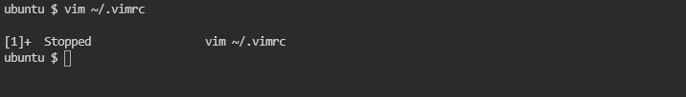

# **SSH Basics**

